Question 1: Student Subject Averages using NumPy
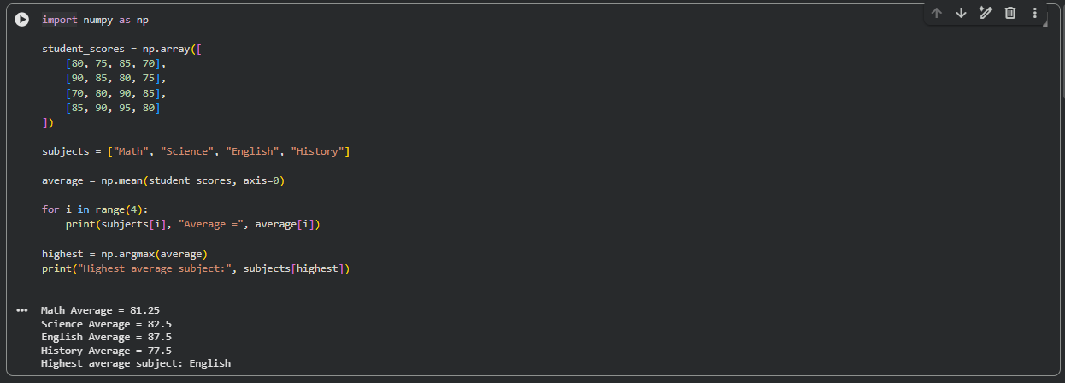

Question 2: Average Product Price using NumPy
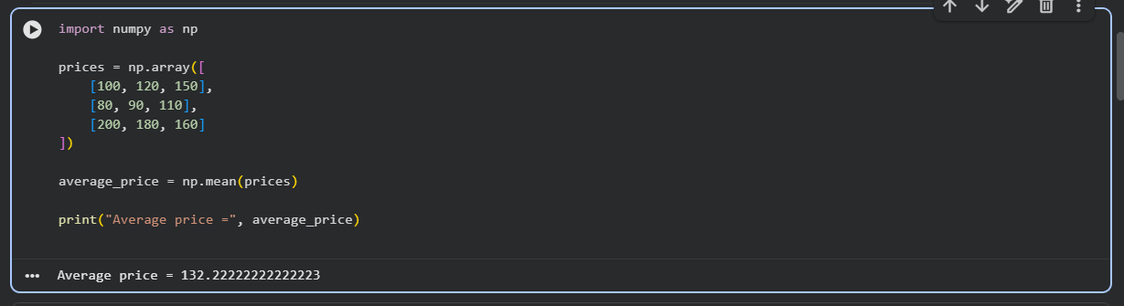

Question 3: Average Sale Price of Houses with More Than 4 Bedrooms
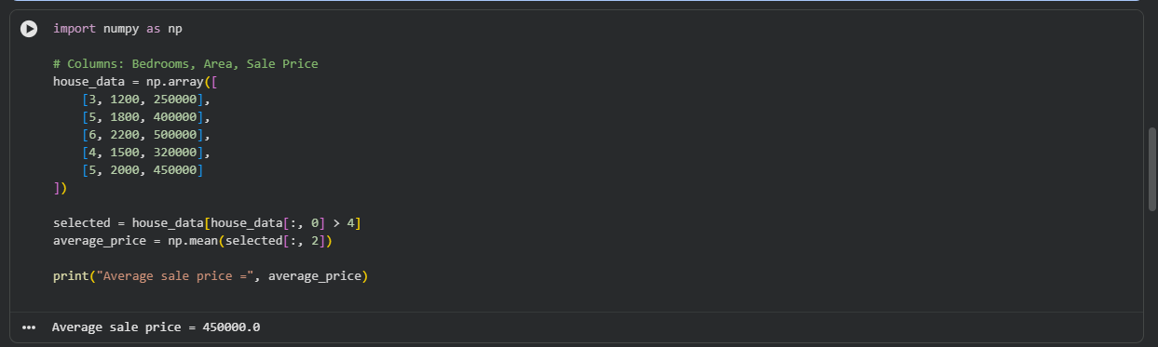

Question 4: Total Yearly Sales and Percentage Increase
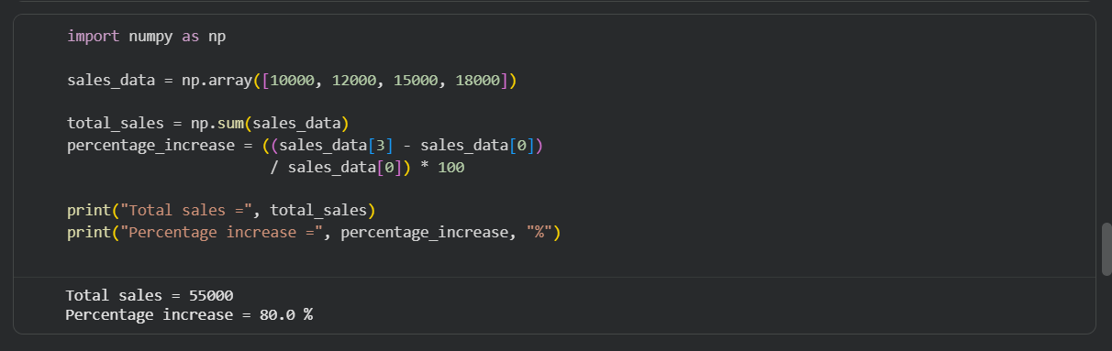

Question 5: Average Fuel Efficiency and Percentage Improvement
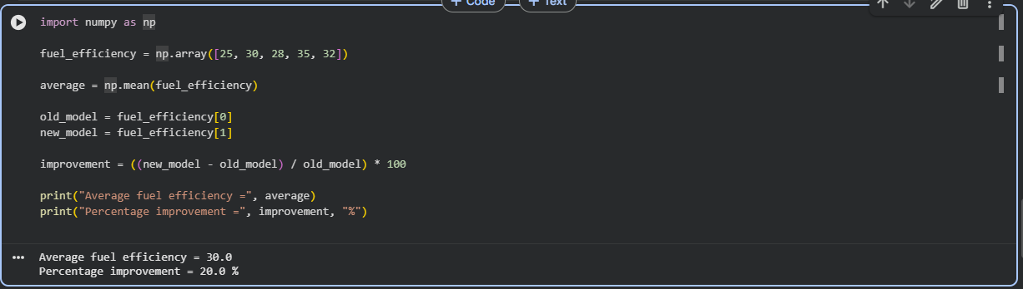
Question 6: Total Grocery Cost with Discount and Tax
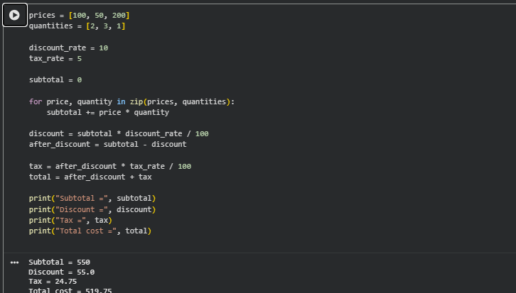
Question 7: Pandas Order Analysis
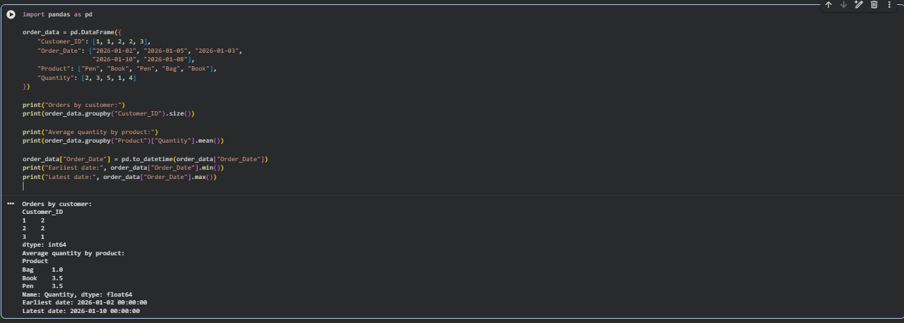
Question 8: Top 5 Products Sold
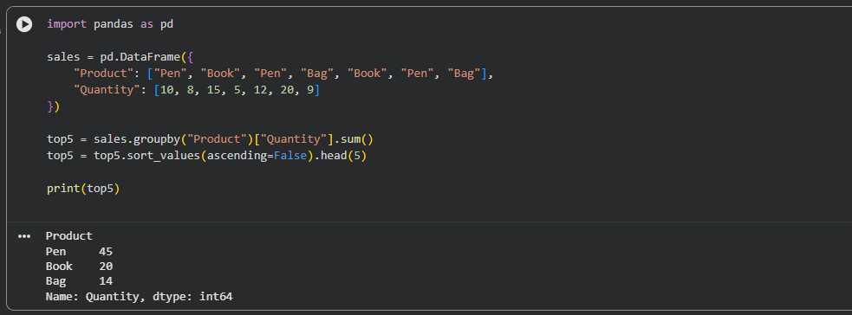
Question 9: Property Data Analysis using Pandas
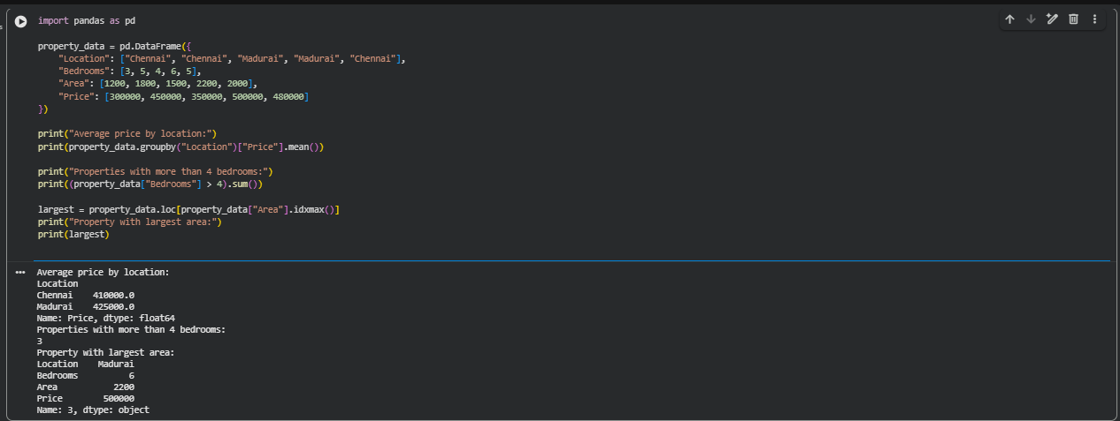

Question 10: Monthly Sales – Line Plot and Bar Plot
import matplotlib.pyplot as plt
months = ["Jan", "Feb", "Mar", "Apr", "May", "Jun"]
sales = [100, 120, 150, 130, 180, 200]
plt.plot(months, sales, marker="o")
plt.title("Monthly Sales - Line Plot")
plt.xlabel("Month")
plt.ylabel("Sales")
plt.show()
plt.bar(months, sales)
plt.title("Monthly Sales - Bar Plot")
plt.xlabel("Month")
plt.ylabel("Sales")
plt.show()
OUTPUT:
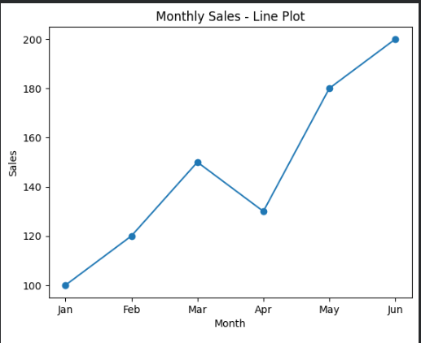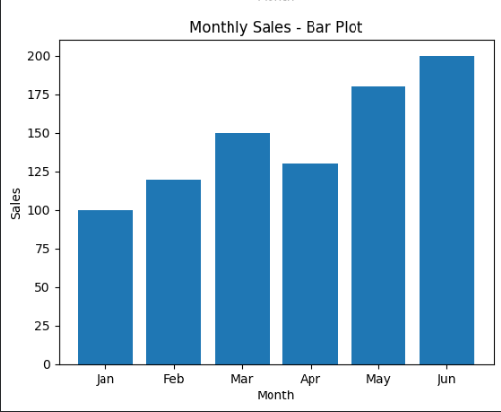

Question 11: Sales over Time – Line, Scatter and Bar Plots
import matplotlib.pyplot as plt
months = [1, 2, 3, 4, 5, 6]
sales = [100, 120, 150, 140, 180, 200]
plt.plot(months, sales, marker="o")
plt.title("Sales over Time")
plt.xlabel("Month")
plt.ylabel("Sales")
plt.show()
plt.scatter(months, sales)
plt.title("Sales - Scatter Plot")
plt.xlabel("Month")
plt.ylabel("Sales")
plt.show()
plt.bar(months, sales)
plt.title("Monthly Sales - Bar Plot")
plt.xlabel("Month")
plt.ylabel("Sales")
plt.show()
OUTPUT:
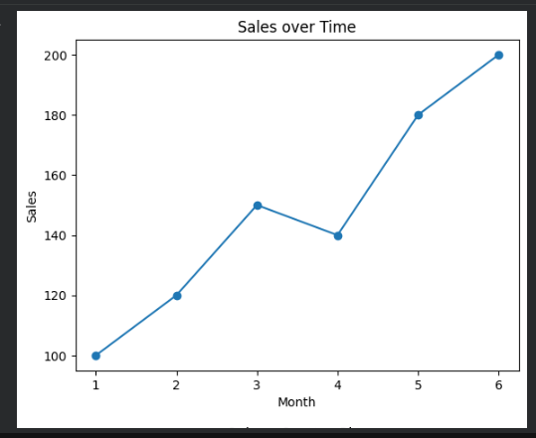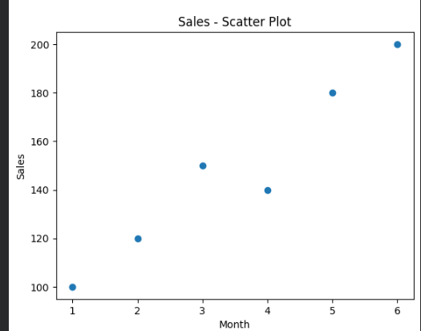

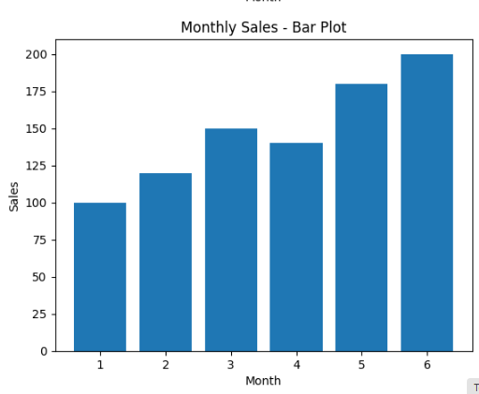
Question 12: Monthly Temperature and Rainfall Plots
import matplotlib.pyplot as plt
months = ["Jan", "Feb", "Mar", "Apr", "May", "Jun"]
temperature = [25, 27, 29, 31, 32, 30]
rainfall = [20, 15, 30, 80, 120, 100]
plt.plot(months, temperature, marker="o")
plt.title("Monthly Temperature")
plt.xlabel("Month")
plt.ylabel("Temperature")
plt.show()
plt.scatter(months, rainfall)
plt.title("Monthly Rainfall")
plt.xlabel("Month")
plt.ylabel("Rainfall")
plt.show()
OUTPUT:
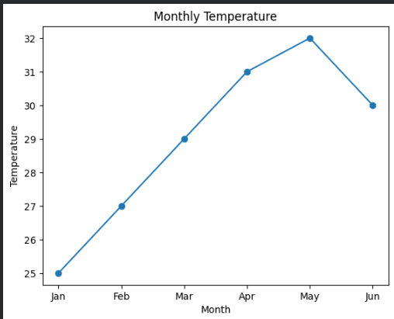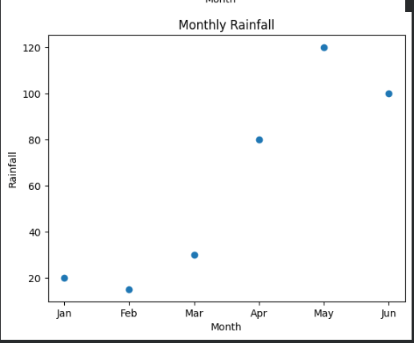
Question 13: Word Frequency from a Text File

